Group 4 presents:

**CSE326 PROJECT:**

CAR RENTAL SYSTEM

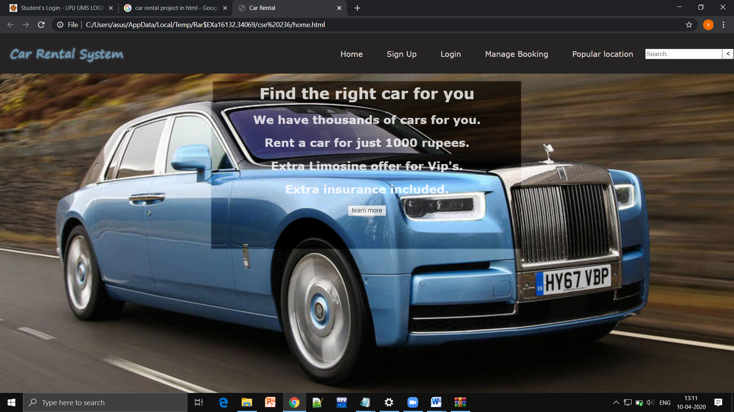

**SUBMITTED BY** **SUBMITTED TO**

A10-JASWINDER SINGH 11908802 ISHAN KUMAR

A11-ADITYA KUMAR 11908894

A12-RONGALA YASWANTH 1190883

**CAR RENTAL SYSTEM**

1. **Introduction:**

This project is designed so as to be used by Car Rental Company specializing in renting cars to customers. It is an online system through which customers can view available cars, register, view profile and book car.

This project consist of 5 webpages:

1. Home page
2. Sign up
3. Login
4. Manage Booking
5. Popular Location
6. **Data Flow Diagram (DFD):**

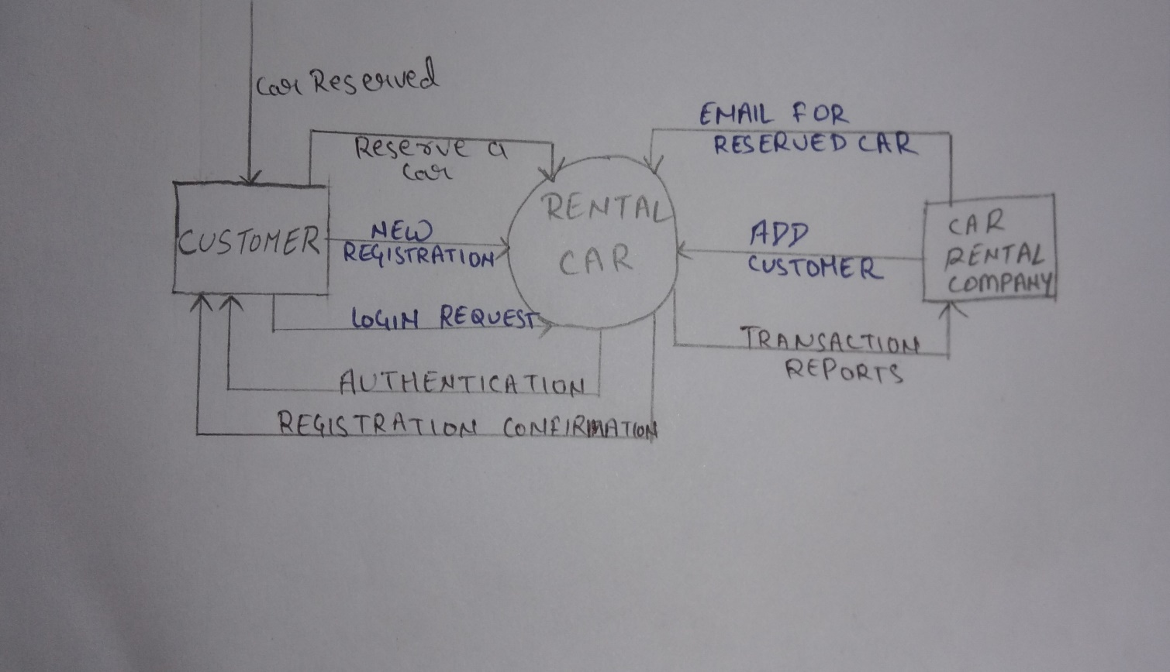

1. HTML Tags used:

* **<a>**
* **<base>**
* **<body>**
* **<button>**
* **<div>**
* **<h1>**
* **<h2>**
* **<head>**
* **<hr>**
* [**<html>**](https://eastmanreference.com/html-element)
* [**<img>**](https://eastmanreference.com/html-image-img-element)
* **<li>**
* **<link>**
* **<p>**
* **<select>**
* **<style>**
* [**<title>**](https://eastmanreference.com/html-page-title-element)
* **<ul>**
* **<center>**
* **<table>**
* **<tr>**
* **<td>**
* **<option>**
* **<label>**
* **<input>**
* **<form>**

1. **Role of Each Group Member**:

Member 1 i.e. jaswinder singh has created the Home page and sign up page. Home page contain the brief introduction of the website. It also contain the price of a car to rent. It also contain the menu option that contains home ,sign up,login,manage booking,popular location. While sign up page will help us to gain new customers to visit our site for more information. This page contain the first name,last name,email id,password,phone number.

Member 2 i.e Aditya kumar has created the login and booking pages.Login page consist of email id/phone number that was used during the sign up process. This will help you to again go to your profile in the website, for more cars to rents.While the booking page contain the location where you want to go after you rent the car,date at which you rent and upto ehat date you will rent,purpose of rental,timing at what time and upto what time you are renting the car.

Member 3 i.e Rongala Yaswanth has created the popular location page that will contain all the popular location across the word to visit.It will help you to explore the word. And he has also collected all the images that are used in the website.

To make the website more attractive in order to gain more customers.

1. **Screenshot of Webpages:**
2. **HOME PAGE:-**

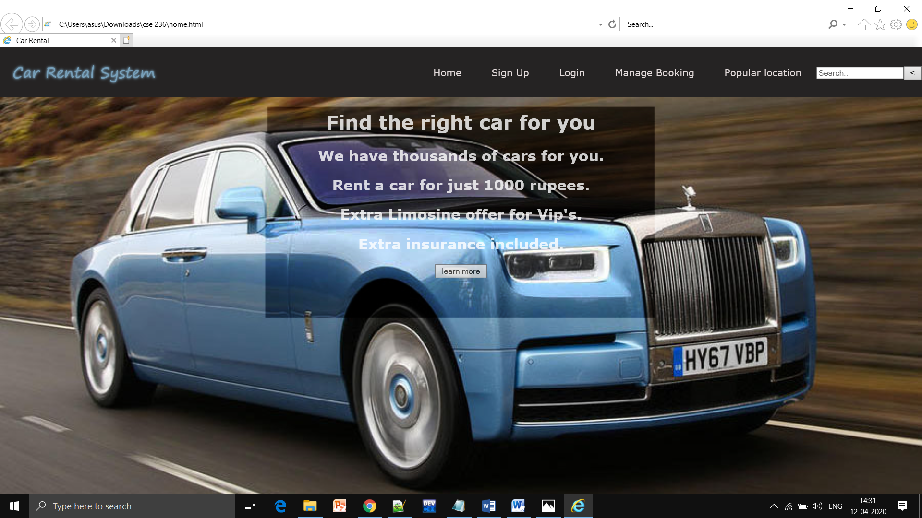

1. **Sign up:-**

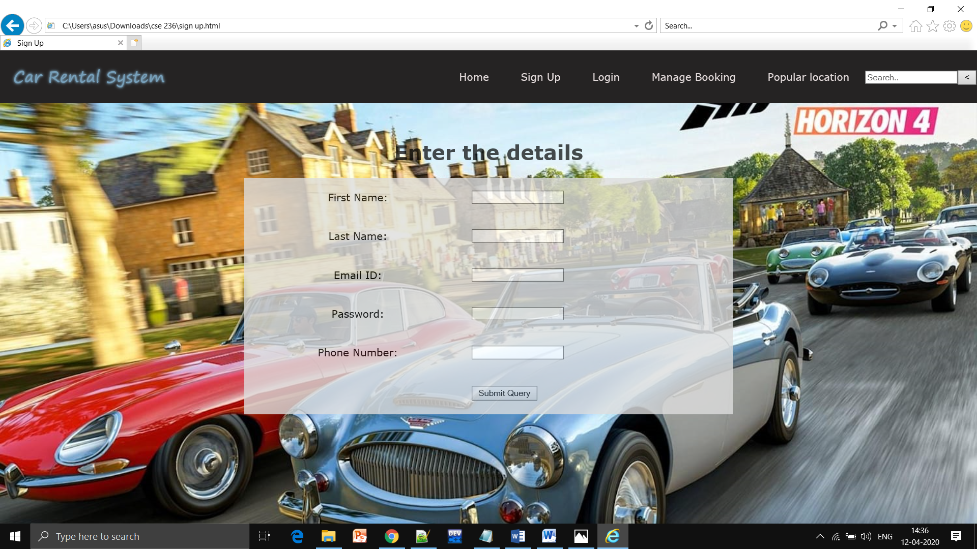

1. **Login:-**

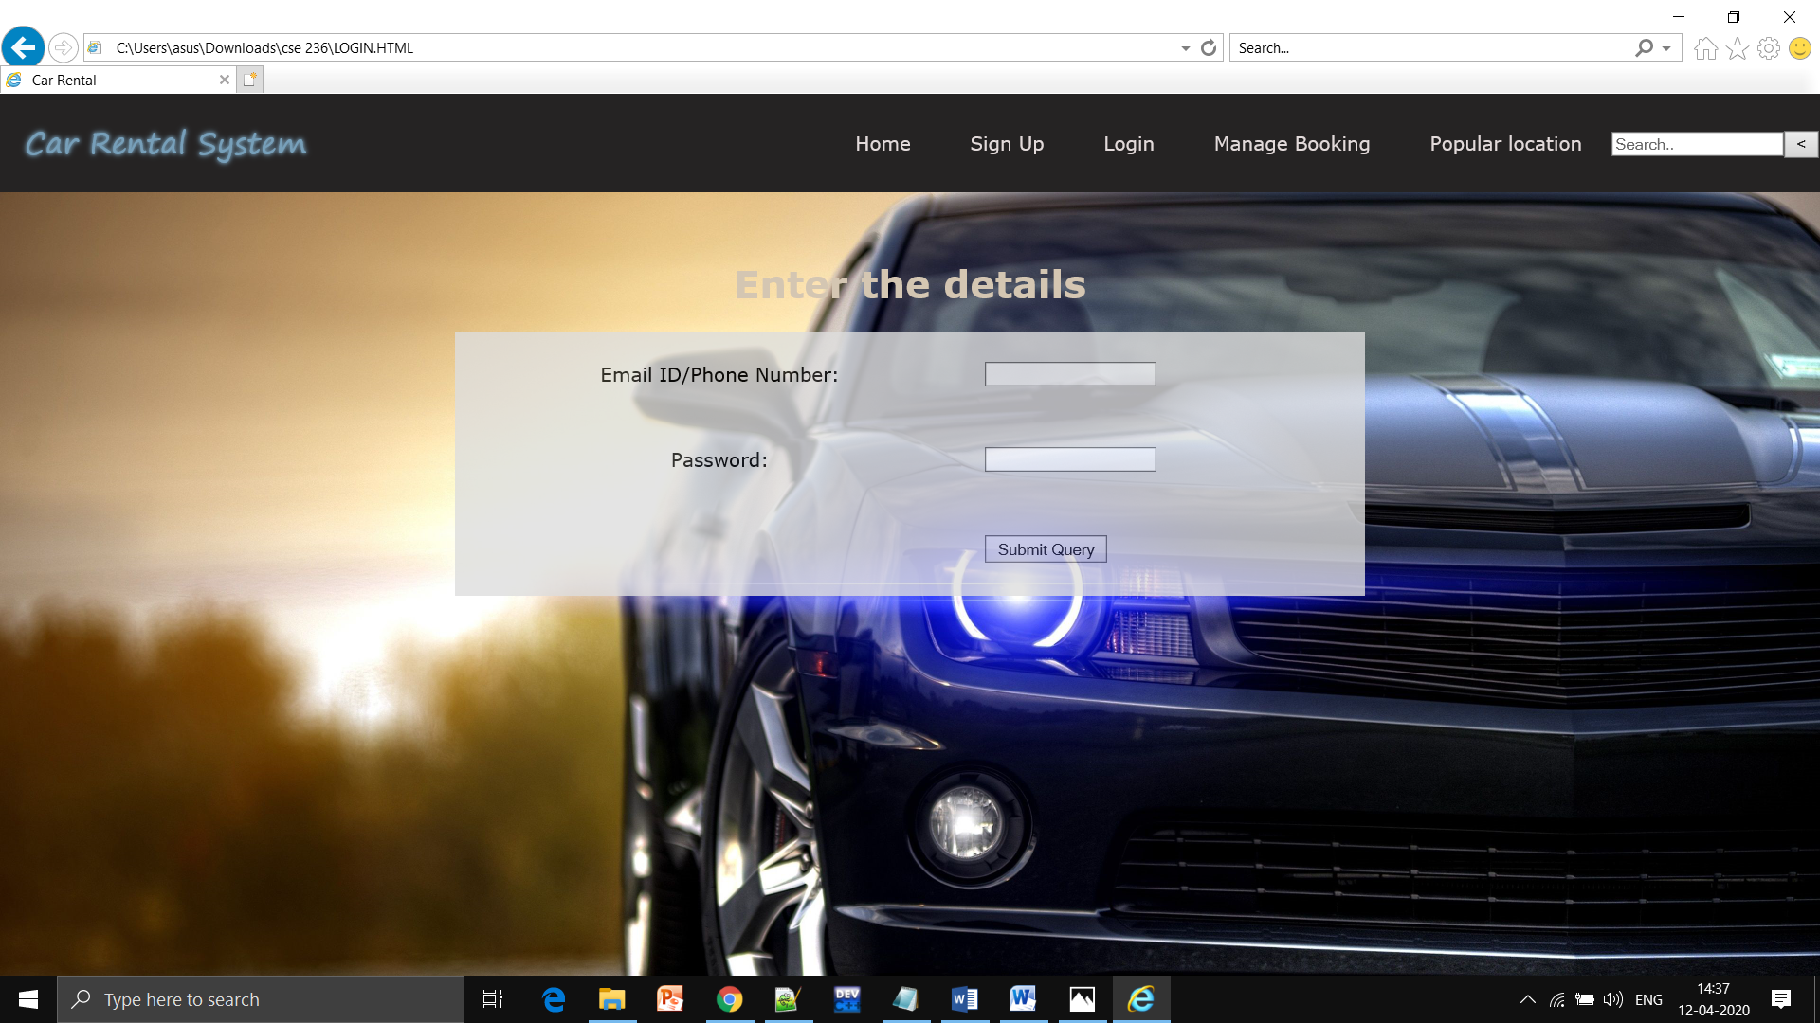

1. **Manage Booking:-**

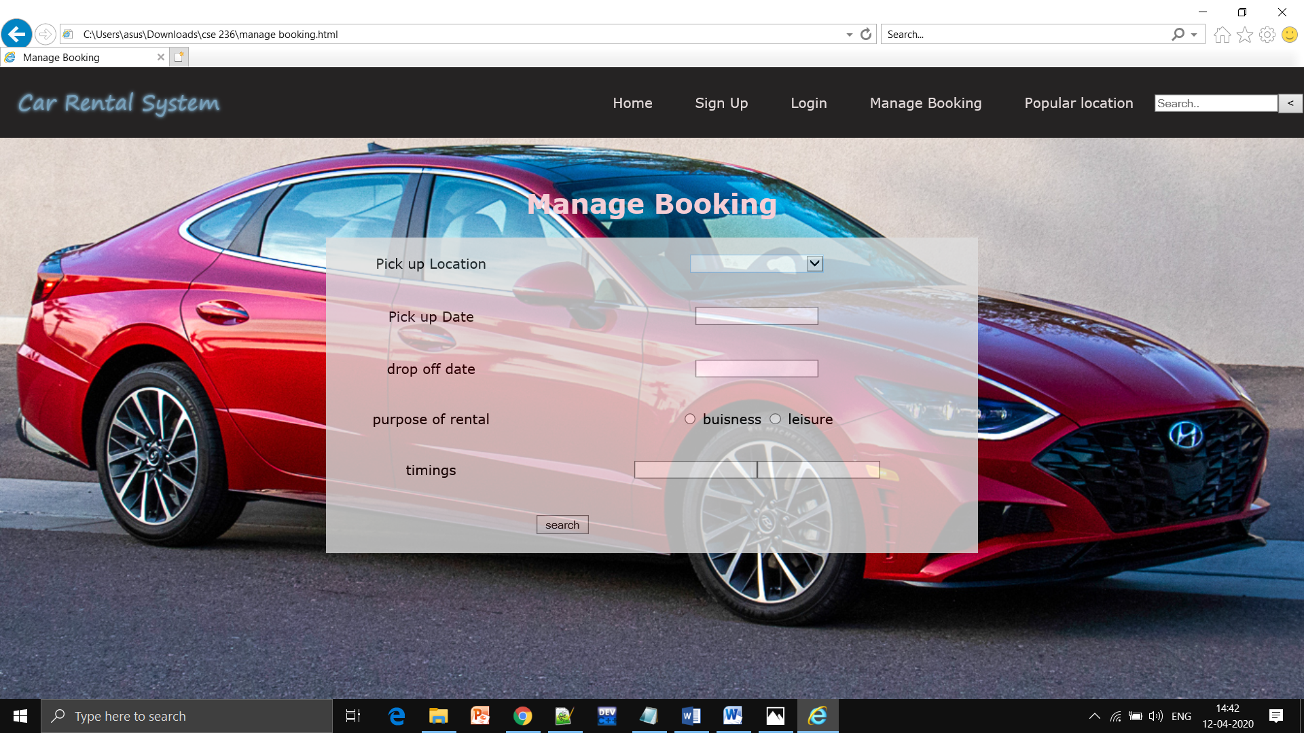

1. **Popular Location:-**

